

**MSPM’S**

**Deogiri Institute of Engineering and Management Studies, Aurangabad**

**Project Topic**

LAPTOPS:

1) Lenovo V130

2) Dell 3567

Submitted By

**Vaishnavi. N. Muley**

**CSE Branch, SE-I and Roll No-26049**

**AND**

**Vyankatesh Dubbewar**

**CSE Branch, SE-I and Roll No-26050**

Under the Guidance of

**Prof. Pankaj Durole**

(Deogiri Institute of Engineering and Management Studies)

2019-2020

CERTIFICATE

This is to Certify that Vaishnavi Muley and Vyankatesh Dubbewar has Completed Word Document Presentation of Computer Architecture and Organization on Survey of Lenovo V130 and Dell 3567 laptops. For the partial fulfillment of Continuous Assessment on date______

**Name and Signature of Student Name and Signature of Subject Teacher**

**CONTENTS:**

|  |  |
| --- | --- |
| **Sr No.** | **Title** |
| **1** | **Introduction** |
| **2** | **Features** |
| **3** | **Processor Architecture** |
|  |  |
|  |  |
|  |  |
|  |  |

Introduction:

LENOVO:



Lenovo was founded in Beijing in November 1984 as **Legend** and was incorporated in Hong Kong in 1988. Lenovo acquired IBM's personal computer business in 2005 and agreed to acquire its Intel-based server business in 2014. Lenovo entered the Smartphone market in 2012 and as of 2014 was the largest vendor of smart phones in Mainland China. In 2014, Lenovo acquired the mobile phone handset maker Motorola Mobility from Google.

Lenovo is listed on the Hong Kong Stock Exchange and is a constituent of the Hang Seng China-Affiliated Corporations Index, often referred to as "Red Chips".

Lenovo laptops fit any budget while offering many designs and features — from basic family laptops, to high-performance gaming notebooks, to stylish multimode devices with smart designs that adapt to your needs. Match a laptop to your lifestyle.

India:

Lenovo has gained significant market share in India through bulk orders to large companies and government agencies. For example, the government of Tamil Nadu ordered a million laptops from Lenovo in 2012 and single-handedly made the firm a market leader. Lenovo distributes most of the personal computers it sells in India through five national distributors such as Ingram Micro and Redington.

Given that most Smartphone and tablets are sold to individuals Lenovo is pursuing a different strategy making use of many small state-centric distributors. Amar Babu, Lenovo's managing director for India, said, "To reach out to small towns and the hinterland, we have tied up with 40 regional distributors. We want our distributors to be exclusive to us. We will, in turn, ensure they have exclusive rights to distribute Lenovo products in their catchment area." As of 2013, Lenovo had about 6,000 retailers selling Smartphone and tablets in India. In February 2013, Lenovo established a relationship with Reliance Communications to sell Smartphone. The Smartphone carried by Reliance have dual-SIM capability and support both GSM and CDMA. Babu claims that the relative under penetration of Smartphone in India represents an opportunity for Lenovo.Lenovo has assembled a team of senior managers familiar with the Indian market, launched mobile phones at all price points there, and worked on branding to build market share. As of February 2014, Lenovo claims that its sales of Smartphone in India have been increasing 100% per quarter while the market is only growing 15-20% over the same period. Lenovo did marketing tests of its Smartphone in November 2012 in Gujarat and some southern cities, where Lenovo already had a strong presence. Lenovo's strategy has been to create awareness, maintain a broad selection of phones at all price points, and develop distribution networks. Lenovo partnered with two national distributors and over 100 local distributors. As of February 2014, more than 7,000 retail outlets in India sold Lenovo Smartphone. Lenovo has also partnered with HCL in order to set up 250 service centers in 110 cities.

In India, Lenovo grants distributors exclusive territories but allows them to sell computers from other companies. Lenovo uses its close relationships with distributors to gain market intelligence and speed up product development.

Lenovo reported a year-on-year increase of about 951% in tablet sales in India for the first quarter of 2014. Canals, a market research firm, said Lenovo took market share away from Apple and Samsung in the country.

Features:

Lenovo:

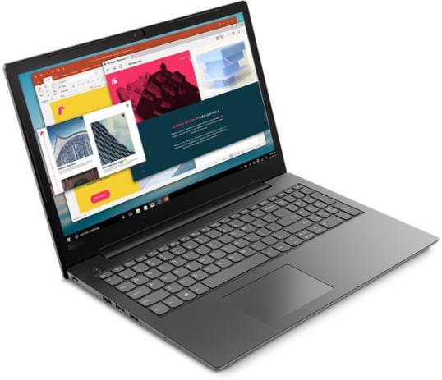

The V130 small-business laptop is perfectly portable, weighing in at just 3.96 pounds (1.8 kg)—yet it features powerful processing and a large 15.6-inch FHD display option, so it's a cinch to work with anywhere. What's more, with the 30 Whr battery option, rapid-charge technology helps to boost productivity levels—in just 30 minutes, the device charges 50%. Plus, it runs up to 6 hours on a single charge. This laptop is highly secure with Trusted Platform Module, which works in conjunction with Windows 10 Pro Bitlocker to encrypt data and passwords. And the privacy camera shutter ensures the webcam is off when it's off—no chance of hackers inconspicuously spying.

With Windows 10 Pro on your V130, you get your very own personal assistant, Cortana. Now, you'll never have to hunt for files, photos, or meetings again—simply let Cortana do the work for you! And when you integrate Cortana with your calendar, you can even search by when and who you worked with on a file, rather than having to remember files names.

Processor Architecture:

Lenovo: It is powered by a Core i3 **processor.**

There are many different processors on the market. However, there are only a few that you should consider purchasing. Whether you're buying a computer off the shelf, building it from scratch or upgrading your CPU, you must put some time and thought into which processor to buy. The choice you make today will affect your computer's speed and functionality for years to come.

Types: There are two primary manufacturers of computer microprocessors. Intel and Advanced Micro Devices (AMD) lead the market in terms of speed and quality. Intel's desktop CPUs include Celeron, Pentium and Core. AMD's desktop processors include Sempron, Athlon and Phenom. Intel makes Celeron M, Pentium M and Core mobile processors for notebooks. AMD makes mobile versions of its Sempron and Athlon, as well as the Turion mobile processor which comes in Ultra and Dual-Core versions. Both companies make both single-core and multi-core processors.

Features: Each processor has a clock speed which is measured in gigahertz (GHz). Also, a processor has a front side bus which connects it with the system's random access memory (RAM.) CPUs also typically have two or three levels of cache. Cache is a type of fast memory which serves as a buffer between RAM and the processor. The processor's socket type determines the motherboard type where it can be installed.

Function: A microprocessor is a silicon chip containing millions of microscopic transistors. This chip functions as the computer's brain. It processes the instructions or operations contained within executable computer programs. Instead of taking instructions directly off of the hard drive, the processor takes its instructions from memory. This greatly increases the computer's speed.

**Size:** When it comes to processors, size matters. Whether you're buying a new computer or upgrading your old one, you must get the fastest processor you can afford. This is because the processor will become obsolete very quickly. Choosing a 3.6 GHz processor over a 2 GHz today can buy you several years of cheap computing time. Also check the speed of the front side bus (FSB) when purchasing your new computer or CPU. A front side bus of 800 MHz or greater is essential for fast processing speeds. The processor's cache is also important. Make sure it has at least 1 MB of last level cache if your computing needs are average. If you're an extreme gamer or if you run intensive graphics programs, get the processor with the largest cache that fits your budget. There can be hundreds of dollars' difference between the cheapest processors and the most expensive ones. However, investing just a little extra cash can get you a much better processor.

Introduction:

Dell:

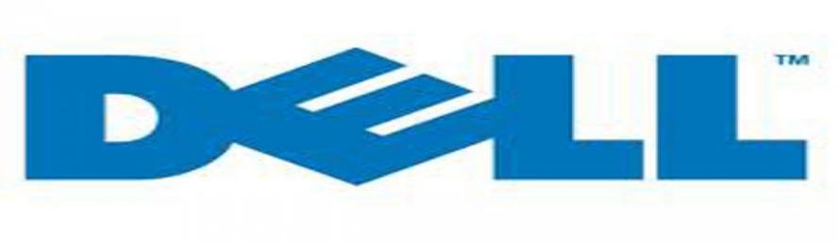

Dell traces its origins to 1984, when Michael Dell created Dell Computer Corporation, which at the time did business as *PC's Limited*,while a student of the University of Texas at Austin. The dorm-room headquartered company sold [IBM PC-compatible](https://en.wikipedia.org/wiki/IBM_PC_compatible) computers built from stock components. Dell dropped out of school to focus full-time on his fledgling business, after getting $1,000 in expansion-capital from his family. In 1985, the company produced the first computer of its own design, the *Turbo PC*, which sold for $795. PC's Limited advertised its systems in national computer magazines for sale directly to consumers and custom assembled each ordered unit according to a selection of options. The company [grossed](https://en.wikipedia.org/wiki/Gross_profit) more than $73 million in its first year of operation.

In 1986, Michael Dell brought in Lee Walker, a 51-year-old venture capitalist, as president and chief operating officer, to serve as Dell's mentor and implement Dell's ideas for growing the company. Walker was also instrumental in recruiting members to the board of directors when the company went public in 1988. Walker retired in 1990 due to health, and Michael Dell hired Morton Meyerson, former CEO and president of [Electronic Data Systems](https://en.wikipedia.org/wiki/Electronic_Data_Systems) to transform the company from a fast-growing medium-sized firm into a billion-dollar enterprise.

The company dropped the PC's Limited name in 1987 to become Dell Computer Corporation and began expanding globally. In June 1988, Dell's market capitalization grew from $30 million to $80 million from its June 22 [initial public offering](https://en.wikipedia.org/wiki/Initial_public_offering) of 3.5 million shares at $8.50 a share. In 1992, [*Fortune*](https://en.wikipedia.org/wiki/Fortune_(magazine)) magazine included Dell Computer Corporation in its list of the world's [500](https://en.wikipedia.org/wiki/Fortune_Global_500) largest companies, making Michael Dell the youngest CEO of a Fortune 500 company ever.

In 1993, to complement its own direct sales channel Dell planned to sell PCs at big-box retail outlets such as Wal-Mart, which would have brought in an additional $125 million in annual revenue. Bain consultant [Kevin Rollins](https://en.wikipedia.org/wiki/Kevin_Rollins) persuaded Michael Dell to pull out of these deals, believing they would be money losers in the long run. Margins at retail were thin at best and Dell left the reseller channel in 1994. Rollins would soon join Dell full-time and eventually become the company President and CEO.

### Growth in the 1990s and early 2000s

Originally, Dell did not emphasize the consumer market, due to the higher costs and unacceptably-low profit margins in selling to individuals and households; this changed when the company's Internet site took off in 1996 and 1997. While the industry's average selling price to individuals was going down, Dell's was going up, as second- and third-time computer buyers who wanted powerful computers with multiple features and did not need much technical support were choosing Dell. Dell found an opportunity among PC-savvy individuals who liked the convenience of buying direct, customizing their PC to their means, and having it delivered in days. In early 1997, Dell created an internal sales and marketing group dedicated to serving the home market and introduced a product line designed especially for individual users.

From 1997 to 2004, Dell enjoyed steady growth and it gained market share from competitors even during industry slumps. During the same period, rival PC vendors such as [Compaq](https://en.wikipedia.org/wiki/Compaq), [Gateway](https://en.wikipedia.org/wiki/Gateway,_Inc.), [IBM](https://en.wikipedia.org/wiki/IBM_Aptiva), [Packard Bell](https://en.wikipedia.org/wiki/Packard_Bell), and [AST Research](https://en.wikipedia.org/wiki/AST_Research) struggled and eventually left the market or were bought out. Dell surpassed Compaq to become the largest PC manufacturer in 1999. Operating costs made up only 10 percent of Dell's $35 billion in revenue in 2002, compared with 21 percent of revenue at Hewlett-Packard, 25 percent at Gateway, and 46 percent at Cisco. In 2002, when Compaq merged with [Hewlett Packard](https://en.wikipedia.org/wiki/Hewlett_Packard) (the fourth-place PC maker), the newly combined Hewlett Packard took the top spot but struggled and Dell soon regained its lead. Dell grew the fastest in the early 2000s.

Dell attained and maintained the top ra

Features:

Dell:

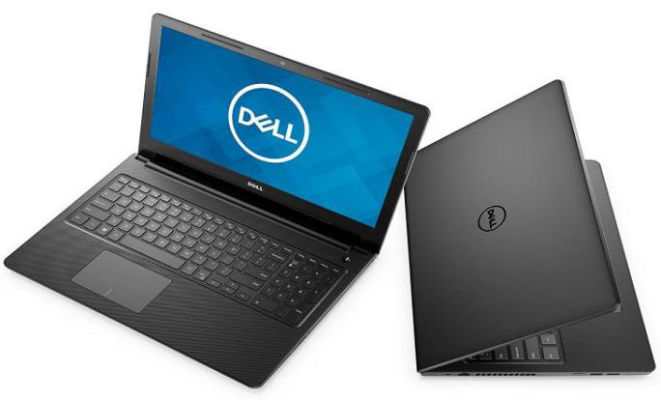

The **Dell Inspiron 15 3567** (3567341TBiB1) features a 15.6-inch HD Truelife LED-Backlit display which outputs a screen resolution of 1,366 x 768 pixels. In order to run the system, there is a 2GHz Intel Core **i3**-6006U processor assisted by a 4GB of DDR4 RAM and an integrated Intel HD 520 graphics card.

General Information

|  |  |  |
| --- | --- | --- |
| Brand |  | Dell |
| Model |  | 15 3567 (3567341TBiB1) |
| Dimensions(WxHxD) |  | 380 x 260 x 23.6  mm |
| Weight |  | 2.2 Kg |
| Colors |  | Black |
| Operating System |  | Windows 10 |
| Operating System Type |  | 64-bit |

Display Details

|  |  |  |
| --- | --- | --- |
| Display Size |  | 15.6 Inches (39.62 cm) |
| Display Resolution |  | 1366 x 768 Pixels |
| Display Type |  | LED |
| Display Features |  | HD Truelife LED-Backlit Display |
| Display Touchscreen |  | no No |

Performance

|  |  |  |
| --- | --- | --- |
| Processor |  | Intel Core i3-6006U (6th Gen) |
| Clock-speed |  | 2.0 Ghz |
| Graphic Processor |  | Intel HD 520 |

Memory

|  |  |  |
| --- | --- | --- |
| Capacity |  | 4 GB |
| RAM type |  | DDR3 |
| RAM speed |  | 1600 Mhz |
| Memory Slots |  | 1 |
| Expandable Memory |  | 16 GB |
| Memory Layout |  | 1 x 4 Gigabyte |

Storage

|  |  |  |
| --- | --- | --- |
| HDD Capacity |  | 1 TB |
| HDD Speed(RPM) |  | 5400 RPM |
| HDD type |  | SATA |

Battery

|  |  |  |
| --- | --- | --- |
| Battery Cell |  | 4 Cell |
| Battery type |  | Li-Ion |
| Battery Life |  | 8 Hrs |

Networking

|  |  |  |
| --- | --- | --- |
| Wireless LAN |  | 802.11 a/b/g/n/ac |
| Bluetooth |  | yes |
| Bluetooth Version |  | 4.1 |

Ports

|  |  |  |
| --- | --- | --- |
| USB 3.0 slots |  | 1 |
| USB 2.0 slots |  | 2 |
| SD Card Reader |  | yes |
| Headphone Jack |  | yes |
| Microphone Jack |  | yes |

Multimedia

|  |  |  |
| --- | --- | --- |
| Web-cam |  | yes |
| Video Recording |  | 720p HD |
| Secondary cam(Rear-facing) |  | no No |
| Audio Solution |  | HD Audio Solution |
| Speakers |  | 2 tuned speakers |
| Sound Technologies |  | Waves MaxxAudio Pro |
| In-built Microphone |  | yes |
| Microphone Type |  | Single Digital Microphone |

Peripherals

|  |  |  |
| --- | --- | --- |
| Optical Drive |  | Tray load DVD Drive (Reads and Writes to DVD/CD) |
| Drive Type |  | DVD Writer |
| Pointing Device |  | Touchpad with Multi-touch Gesture support |
| Keyboard |  | Standard Keyboard |
| Fingerprint Scanner |  | no No |

|  |  |  |
| --- | --- | --- |
| Warranty |  | 1 Year |
| Sales Package |  | Laptop, Battery, AC Adapter, User Guide |

Processor :

Developed and manufactured by [Intel](https://www.computerhope.com/comp/intel.htm), the **Core i3** is a dual-core computer processor, available for use in both desktop and laptop computers. It is one of three types of processors in the "i" series (also called the Intel Core family of processors).

The Core i3 processor is available in multiple speeds, ranging from 1.30 GHz up to 3.50 GHz, and features either 3 MB or 4 MB of [cache](https://www.computerhope.com/jargon/c/cache.htm). It utilizes either the LGA 1150 or LGA 1155 socket on a [motherboard](https://www.computerhope.com/jargon/m/mothboar.htm). Core i3 processors are most often found as dual-core, having two cores. However, a select few high-end Core i3 processors are quad-core, featuring four cores.

The most common type of [RAM](https://www.computerhope.com/jargon/r/ram.htm) used with a Core i3 processor is DDR3 1333 or DDR3 1600.

Power usage varies for the Core i3 processors:

* Slower speeds (1.30 GHz to 1.80 GHz) use 11.5 W, 15 W or 25 W of power
* Medium speeds (2.00 GHz to 2.50 GHz) use 28 W, 35 W or 37 W of power
* Faster speeds (2.90 GHz to 3.50 GHz) use 35 W, 37 W or 54 W of power

Core i3 processors are often used in laptop computers, due to their lower heat generation and conservative battery usage. Some laptops can be used for up to five or six hours on a single battery charge when running a Core i3 processor.

Archestructure of **Processor**

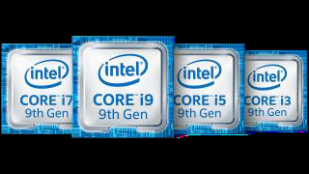

A processor is the logic circuitry that responds to and processes the basic instructions that drive a computer. The four primary functions of a processor are fetch, decode, execute and writeback.

The basic elements of a processor:

The arithmetic logic unit (ALU), which carries out arithmetic and logic operations on the operands in instructions.

The floating point unit (FPU), also known as a math coprocessor or numeric coprocessor, a specialized coprocessor that manipulates numbers more quickly than the basic microprocessor circuitry can.

Registers, which hold instructions and other data. Registers supply operands to the ALU and store the results of operations.

L1 and L2 cache memory. Their inclusion in the CPU saves time compared to having to get data from random access memory (RAM).

Most processors today are multi-core, which means that the IC contains two or more processors for enhanced performance, reduced power consumption and more efficient simultaneous processing of multiple tasks (s*ee:* parallel processing). Multi-core set-ups are similar to having multiple, separate processors installed in the same 2

computer, but because the processors are actually plugged into the same socket, the connection between them is faster.

The term *processor* is used interchangeably with the term central processing unit (CPU), although strictly speaking, the CPU is not the only processor in a computer. The GPU (graphics processing unit) is the most notable example but the hard drive and other devices within a computer also perform some processing independently. Nevertheless, the term *processor* is generally understood to mean the CPU.

The processor in a personal computer or embedded in small devices is often called a microprocessor. That term simply means that the processor's elements are contained on a single integrated circuitry (IC) chip.

The two main competitors in the processor market are Intel and AMD. 3 4

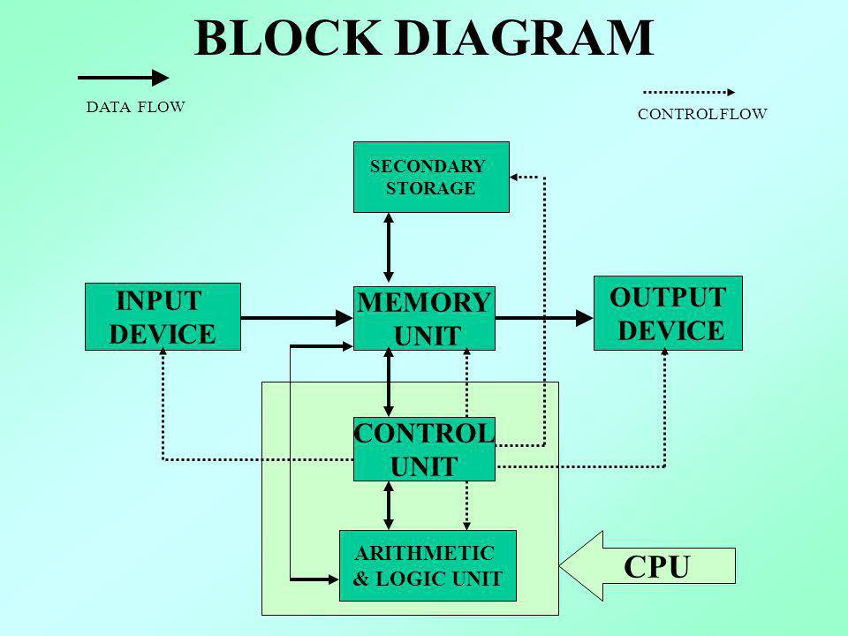

**Architecture** 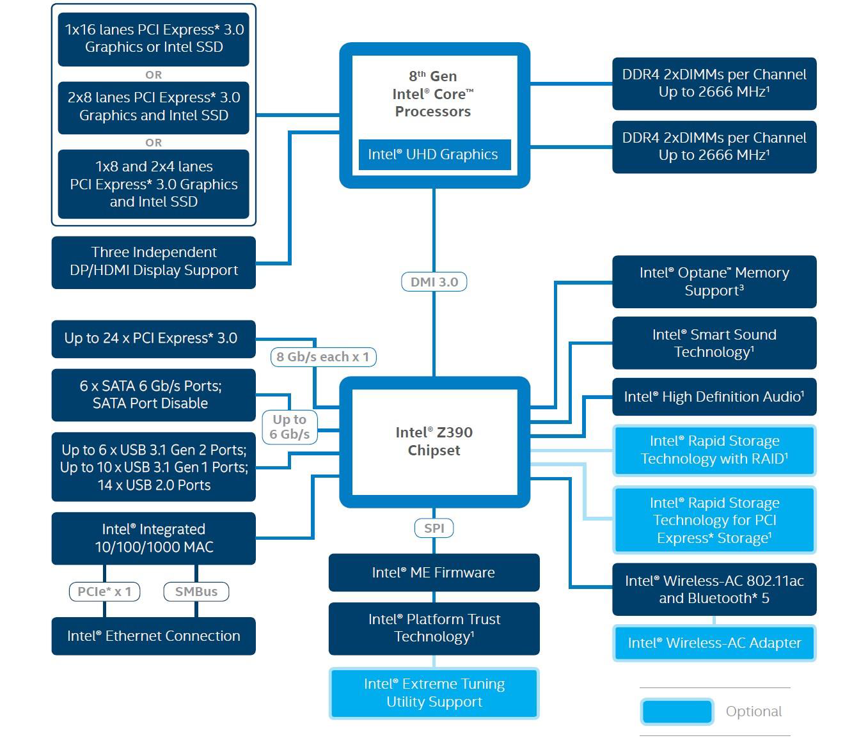

The word "architecture" typically refers to building design and construction. In the computing world, "architecture" also refers to design, but instead of buildings, it describes the design of computer systems. Computer architecture is a broad topic that includes everything from the relationship between multiple computers (such as a "client-server" model) to specific components inside a computer.

The most important type of hardware design is a computer's processor architecture. The design of the processor determines what software can run on the computer and what other hardware components are supported. For example, Intel's x86 processor architecture is the standard architecture used by most PCs. By using this design, computer manufacturers can create machines that include different hardware components, but run the same software. Several years ago, Apple switched from the PowerPC architecture to the x86 architecture to make the Macintosh platform more compatible with Windows PCs.

The architecture of the motherboard is also important in determining what hardware and software a computer system will support. The motherboard design is often called the "chipset" and defines what processor models and other components will work with the motherboard. For example, while two motherboards may both support x86 processors, one may only work with newer processor models. A newer chipset may also require faster RAM and a different type of video card than an older model.

NOTE: Most modern computers have 64-bit processors and chipsets, while earlier computers used a 32-bit architecture. A computer with a 64-bit chipset supports far more memory than one with a 32-bit chipset and can run software designed specifically for 64-bit processors.

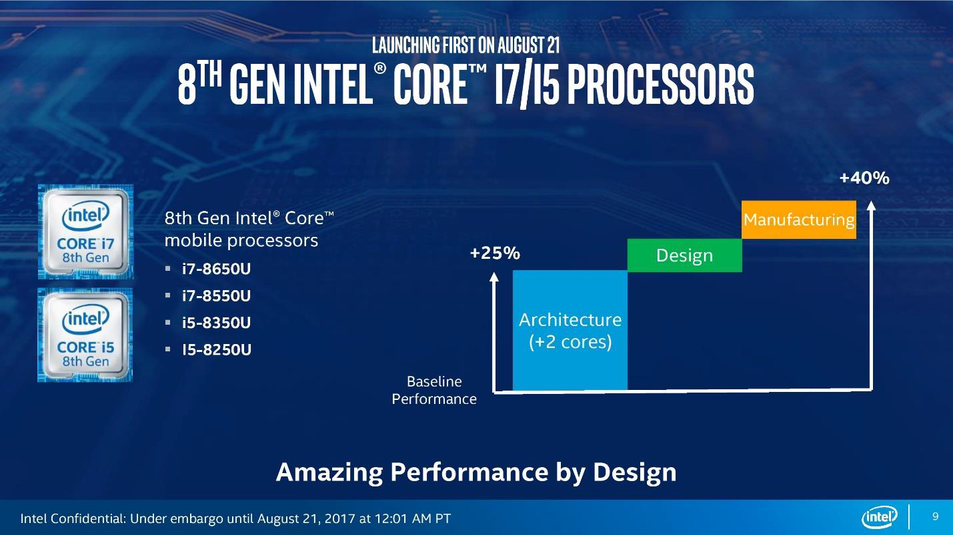

**GPU**

(**G**raphics **P**rocessing **U**nit) A programmable logic chip (processor) specialized for display functions. The GPU renders images, animations and video for the computer's screen. GPUs are located on plug-in cards, in a chipset on the motherboard or in the same chip as the CPU. A GPU performs parallel operations. Although it is used for 2D data as well as for zooming and panning the screen, a GPU is essential for smooth decoding and rendering of 3D animations and video. The more sophisticated the GPU, the higher the resolution and the faster and smoother the motion in games and movies. GPUs on stand-alone cards include their own memory, while GPUs built into the chipset or CPU chip share main memory with the CPU.

**Not Just Graphics Processing** Since GPUs perform parallel operations on multiple sets of data, they are increasingly used as vector processors for non-graphics applications that require repetitive computations. For example, in 2010, a Chinese supercomputer achieved the record for top speed using more than seven thousand GPUs in addition to its CPUs. 8 9

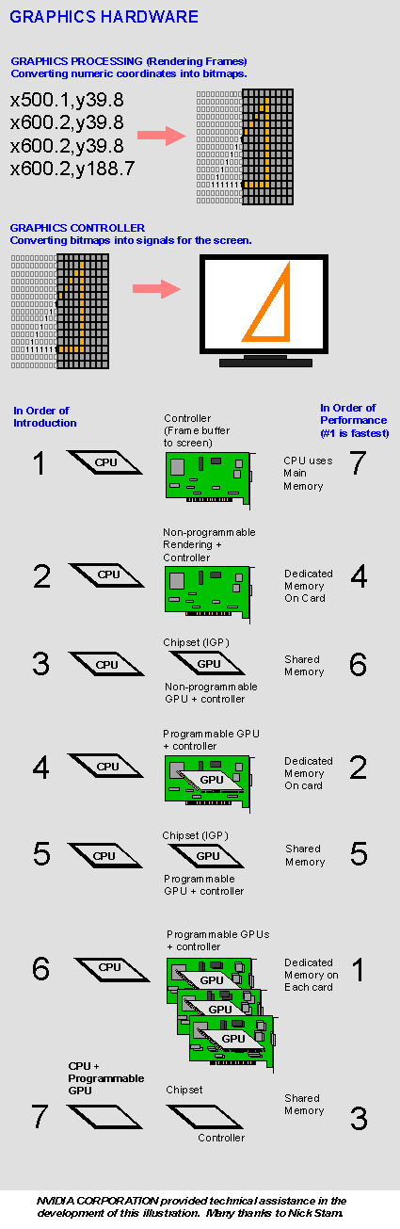

**Graphics Hardware Locations**

In a PC, graphics rendering originally took place in the CPU. Over time, functions were offloaded to separate circuits and then to GPUs either in separate cards, the PC's chipset or the CPU chip itself. See display adapter, integrated graphics and integrated GPU.

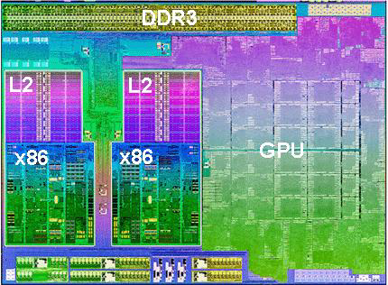

**An Integrated GPU**

This Trinity chip from AMD integrates a sophisticated GPU with four cores of x86 processing and a DDR3 memory controller. Each x86 section is a dual-core CPU with its own L2 cache.

**History of GPUs**

Specialized chips for processing graphics have existed since the dawn of video games in the 1970s. Graphics processing units came to high-performance enterprise computers in the late 1990s, and NVIDIA introduced the first GPU for personal computers, the GeForce 256, in 1999. 10

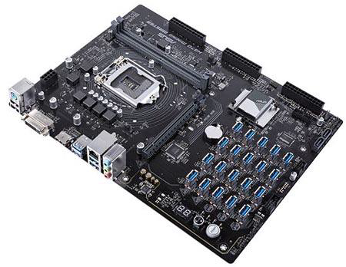

Over time, the processing power of GPUs made the chips a popular choice for other resource-intensive tasks unrelated to graphics. Early applications included scientific calculations and modeling; by the mid-2010s, GPU computing also powered machine learning and artificial intelligence software.

In 2012, NVIDIA released a virtualized GPU, which offloads graphics processing power from the server CPU in a virtual desktop infrastructure. Graphics performance has traditionally been one of the most common complaints among users of virtual desktops and applications, and virtualized GPUs aim to address that problem. 11



**RAM (Random Access Memory)**

RAM (Random Access Memory) is the hardware in a computing device where the operating system (OS), application programs and data in current use are kept so they can be quickly reached by the device's processor. RAM is the main memory in a computer, and it is much faster to read from and write to than other kinds of storage, such as a hard disk drive (HDD), solid-state drive (SSD) or optical drive.

Random Access Memory is volatile. That means data is retained in RAM as long as the computer is on, but it is lost when the computer is turned off. When the computer is rebooted, the OS and other files are reloaded into RAM, usually from an HDD or SSD.

What Random Access Memory is used for?

Because of its volatility, Random Access Memory can't store permanent data. RAM can be compared to a person's short-term memory, and a hard drive to a person's long-term memory. Short-term memory is focused on immediate work, but it can only keep a limited number of facts in view at any one time. When a person's short-term memory fills up, it can be refreshed with facts stored in the brain's long-term memory.

A computer also works this way. If RAM fills up, the computer's processor must repeatedly go to the hard disk to overlay the old data in RAM with new data. This process slows the computer's operation. 12

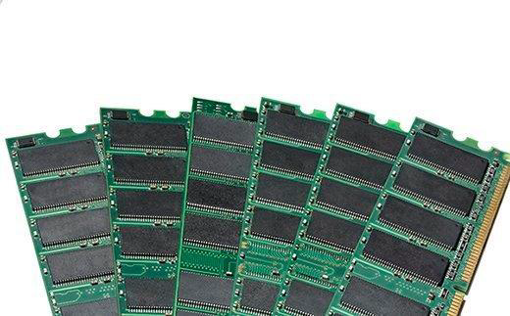

RAM modules

A computer's hard disk can become completely full of data and unable to take any more, but RAM won't run out of memory. However, the combination of RAM and storage memory can be completely used up.

How does RAM work?

The term *random access* as applied to RAM comes from the fact that any storage location, also known as any memory address, can be accessed directly.

Originally, the term *Random Access Memory* was used to distinguish regular core memory from offline memory.

Offline memory typically referred to magnetic tape from which a specific piece of data could only be accessed by locating the address sequentially, starting at the beginning of the tape. RAM is organized and controlled in a way that enables data to be stored and retrieved directly to and from specific locations. 13

Other types of storage -- such as the hard drive and CD-ROM -- are also accessed directly or randomly, but the term *random access* isn't used to describe these other types of storage.

RAM is similar in concept to a set of boxes in which each box can hold a 0 or a 1. Each box has a unique address that is found by counting across the columns and down the rows. A set of RAM boxes is called an array, and each box is known as a cell.

To find a specific cell, the RAM controller sends the column and row address down a thin electrical line etched into the chip. Each row and column in a RAM array has its own address line. Any data that's read flows back on a separate data line.

RAM is physically small and stored in microchips. It's also small in terms of the amount of data it can hold.

A typical laptop computer may come with 8 gigabytes of RAM, while a hard disk can hold 10 terabytes.

RAM microchips are gathered together into memory modules, which plug into slots in a computer's motherboard. A bus, or a set of electrical paths, is used to connect the motherboard slots to the processor.

A hard drive, on the other hand, stores data on the magnetized surface of what looks like a vinyl record. And, alternatively, an SSD stores data in memory chips that, unlike RAM, are nonvolatile, don't depend on having constant power and won't lose data once the power is turned off.

Most PCs enable users to add RAM modules up to a certain limit. Having more RAM in a computer cuts down on the number of times the processor must read data from the hard disk, an operation that takes longer than reading data from RAM. RAM access time is in nanoseconds, while storage memory access time is in milliseconds. Types of Random Access Memory 14

RAM comes in two primary forms:

**Dynamic Random Access Memory (DRAM)** makes up the typical computing device's RAM and, as was previously noted, it needs that power to be on to retain stored data.

Each DRAM cell has a charge or lack of charge held in an electrical capacitor. This data must be constantly refreshed with an electronic charge every few milliseconds to compensate for leaks from the capacitator. A transistor serves as a gate, determining whether a capacitor's value can be read or written.

**Static Random Access Memory (SRAM)** also needs constant power to hold on to data, but it doesn't need to be continually refreshed the way DRAM does.

In SRAM, instead of a capacitor holding the charge, the transistor acts as a switch, with one position serving as 1 and the other position as 0. Static RAM requires several transistors to retain one bit of data compared to dynamic RAM which needs only one transistor per bit. As a result, SRAM chips are much larger and more expensive than an equivalent amount of DRAM.

However, SRAM is significantly faster and uses less power than DRAM. The price and speed differences mean static RAM is mainly used in small amounts as cache memory inside a computer's processor. 15

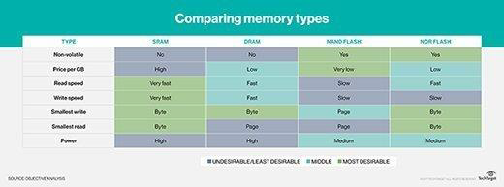

History of RAM: RAM vs. SDRAM

RAM was originally asynchronous because the RAM microchips had a different clock speed than the computer's processor. This was a problem as processors became more powerful and RAM couldn't keep up with the processor's requests for data.

In the early 1990s, clock speeds were synchronized with the introduction of synchronous dynamic RAM, or SDRAM. By synchronizing a computer's memory with the inputs from the processor, computers were able to execute tasks faster.

However, the original single data rate SDRAM (SDR SDRAM) reached its limit quickly. Around the year 2000, double data rate synchronous Random Access Memory (DDR SRAM) was developed. This moved data twice in a single clock cycle, at the start and the end.

DDR SDRAM has evolved three times, with DDR2, DDR3 and DDR4, and each iteration has brought improved data throughput speeds and reduced power use. However, each DDR version has been incompatible with earlier ones because, with each iteration, data is handled in larger batches.

The JEDEC Solid State Technology Association has been working on the fifth generation of DDR technology, or DDR5 SDRAM, for several years, and it plans to release the full standard in June 2018. 16

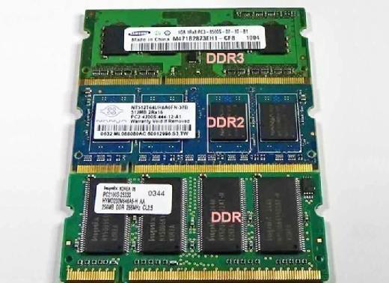

GDDR SDRAM

Graphics double data rate (GDDR) SDRAM is used in graphics and video cards. Like DDR SDRAM, the technology enables data to be moved at various points in a CPU clock cycle. However, it runs at higher voltages and has less strict timing than DDR SDRAM.

With parallel tasks, such as 2D and 3D video rendering, tight access times aren't as necessary, and GDDR can enable the higher speeds and memory bandwidth needed for GPU performance.

Similar to DDR, GDDR has gone through several generations of development, with each providing more performance and lower power consumption. GDDR6 is the latest generation of graphics memory. 17

RAM vs. virtual memory

A computer can run short on memory, especially when running multiple programs simultaneously. Operating systems can compensate for physical memory shortfalls by creating virtual memory.

With virtual memory, data is temporarily transferred from RAM to disk storage, and virtual address space is increased using active memory in RAM and inactive memory in an HDD to form contiguous addresses that hold an application and its data. Using virtual memory, a system can load larger programs or multiple programs running at the same time, letting each operate as if it has infinite memory without having to add more RAM.

Virtual memory is able to handle twice as many addresses as RAM. A program's instructions and data are initially stored at virtual addresses, and once the program is executed, those addresses are turned into actual memory addresses.

One downside to virtual memory is that it can slow a computer because data must be mapped between the virtual and physical memory. With physical memory alone, programs work directly from RAM.

RAM vs. flash memory

Flash memory and RAM are both comprised of solid-state chips, but they play different roles in computer systems because of differences in the way they're made, their performance specifications and cost. Flash memory is used for storage memory, while RAM is used as active memory that performs calculations on the data retrieved from storage.

One significant difference between RAM and flash memory is that data must be erased from NAND flash memory in entire blocks, making it slower than RAM, where data can be erased in individual bits. 18

However, NAND flash memory is less expensive than RAM, and it's also nonvolatile; unlike RAM, it can hold data even when the power is off. Because of its slower speed, nonvolatility and lower cost, flash is often used for storage memory in SSDs.

RAM vs. ROM

Read-only memory, or ROM, is computer memory containing data that can only be read, not written to. ROM contains boot-up programming that is used each time a computer is turned on. It generally can't be altered or reprogrammed.

The data in ROM is nonvolatile and isn't lost when the computer power is turned off. As a result, read-only memory is used for permanent data storage. Random Access Memory, on the other hand, can only hold data temporarily. ROM is generally several megabytes of storage, while RAM is several gigabytes.

Trends and future directions

Resistive Random Access Memory (RRAM or ReRAM) is nonvolatile storage that can alter the resistance of the solid dielectric material it's composed of. ReRAM devices contain a memristor in which the resistance varies when different voltages are applied.

ReRAM creates oxygen vacancies, which are physical defects in a layer of oxide material. These vacancies represent two values in a binary system, similar to a semiconductor's electrons and holes.

ReRAM has a higher switching speed compared to other nonvolatile storage technologies, such as NAND flash. It also holds the promise of high storage density and less power consumption than NAND flash, making ReRAM a good option for memory in sensors used for industrial, automotive and internet of things applications. 19

Vendors have struggled for years to develop ReRAM technology and get chips into production. A few vendors are currently shipping them.

3D XPoint technology, such as Intel's Optane, could eventually fill the gap between dynamic RAM and NAND flash memory. 3D XPoint has a transistor-less, cross-point architecture in which selectors and memory cells are at the intersection of perpendicular wires. 3D XPoint isn't as fast as DRAM, but it is nonvolatile memory. 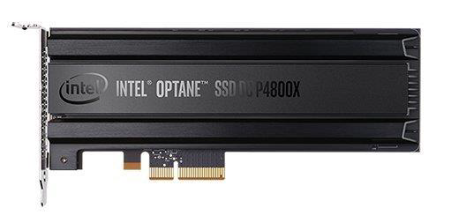

Intel's 3D XPoint-based Optane SSD

In terms of performance and price, 3D XPoint technology is between fast, but costly DRAM and slower, less expensive NAND flash. As the technology develops, it may blur the distinction between RAM and storage. 20

**Storage**

Data storage is the collective methods and technologies that capture and retain digital information on electromagnetic, optical or silicon-based storage media. Storage is a key component of digital devices, as consumers and businesses have come to rely on it to preserve information ranging from personal photos to business-critical information.

Storage is frequently used to describe the devices and data connected to the computer through input/output (I/O) operations, including hard disks, flash devices, tape systems and other media types.

Why data storage is important ?

Underscoring the importance of storage is a steady climb in the generation of new data, which is attributable to big data and the profusion of internet of things (IoT) devices. Modern storage systems require enhanced capabilities to allow enterprises to apply machine learning-enabled artificial intelligence (AI) to capture this data, analyze it and wring maximum value from it.

Larger application scripts and real-time database analytics have contributed to the advent of highly dense and scalable storage systems, including high-performance computing storage, converged infrastructure, composable storage systems, hyper-converged storage infrastructure, scale-out and scale-up network-attached storage (NAS) and object storage platforms.

By 2025, it is expected that 163 zettabytes (ZB) of new data will be generated, according to a report by IT analyst firm IDC. That estimate represents a potential tenfold increase from the 16 ZB produced through 2016. 21

How data storage works ?

The term *storage* may refer both to a user's data generally and, more specifically, to the integrated hardware and software systems used to capture, manage and prioritize the data. This includes information in applications, databases, data warehouses, archiving, backup appliances and cloud storage.

Digital information is written to target storage media through the use of software commands. The smallest unit of measure in a computer memory is a bit, described with a binary value of 0 or 1, according to the level of electrical voltage contained in a single capacitor. Eight bits make up one byte.

Other capacity measurements to know are:

* • kilobit (Kb)
* • megabit (Mb)
* • gigabit (Gb)
* • terabit (Tb)
* • petabit (Pb)
* • exabit (Eb)

Larger measures include:

* • kilobyte (KB) equal to 1,024 bytes
* • megabyte (MB) equal to 1,024 KB
* • gigabyte (GB) equal to 1,024 MB
* • terabyte (TB) equal to 1,024 GB
* • petabyte (PB) equal to 1,024 TB
* • exabyte (EB) equal to 1,024 PB

22

Few organizations require a single storage system or connected system that can reach an exabyte of data, but there are storage systems that scale to multiple petabytes.

Data storage capacity requirements define how much storage is needed to run an application, a set of applications or data sets. Capacity requirements take into account the types of data. For instance, simple documents may only require kilobytes of capacity, while graphic-intensive files, such as digital photographs, may take up megabytes, and a video file can require gigabytes of storage. Computer applications commonly list the minimum and recommended capacity requirements needed to run them.

On an electromechanical disk, bytes store blocks of data within sectors. A hard disk is a circular platter coated with a thin layer of magnetic material. The disk is inserted on a spindle and spins at speeds of up to 15,000 revolutions per minute (rpm). As it rotates, data is written on the disk surface using magnetic recording heads. A high-speed actuator arm positions the recording head to the first available space on the disk, allowing data to be written in a circular fashion.

A sector on a standard disk is 512 bytes. Recent advances in disk include shingled magnetic recording, in which data writes occur in overlapping fashion to boost the platter's areal density.

On solid-state drives (SSDs), data is written to pooled NAND flash, designed with floating gate transistors that enable the cell to retain an electrical charge. An SSD is not technically a drive, but it exhibits design characteristics similar to an integrated circuit, featuring potentially millions of nano transistors placed on millimeter-sized silicon chips.

Backup data copies are written to disk appliances with the aid of a hierarchical storage management system. And although less commonly practiced than in years past, the tactic of some organizations remains to write disk-based backup data 23

to magnetic tape as a tertiary storage tier. This is a best practice in organizations subject to legal regulations.

A virtual tape library (VTL) uses no tape at all. It is a system in which data is written sequentially to disks, but retains the characteristics and properties of tape. The value of a VTL is its quick recovery and scalability.

Evaluating the storage hierarchy

Organizations increasingly use tiered storage to automate data placement on different storage media, based on an application's capacity, compliance and performance requirements.

Enterprise data storage is often classified as primary and secondary storage, depending on how the data is used and the type of media it requires. Primary storage handles application workloads central to a company's day-to-day production and main lines of business.

Primary storage is occasionally referred to as *main storage* or *primary memory*. Data is held in random access memory (RAM) and other built-in devices, such as the processor's L1 cache. Secondary storage encompasses data on flash, hard disk, tape and other devices requiring I/O operations. Secondary storage media is often used in backup and cloud storage.

Primary storage generally provides faster access than secondary storage due to the proximity of storage to the computer processor. On the other hand, secondary storage can hold much more data than primary storage. Secondary storage also replicates inactive data to a backup storage device, yet keeps it highly available in case it is needed again.

Digital transformation of business has prompted more and more companies to deploy multiple hybrid clouds, adding a remote tier to buttress local storage. 24

Types of data storage devices/mediums

Data storage media have varying levels of capacity and speed. These include cache memory, dynamic RAM (DRAM) or main memory; magnetic tape and magnetic disk; optical disc, such as CDs, DVDs and Blu-ray disks; flash memory and various iterations of in-memory storage; and cache memory.

Along with main memory, computers contain nonvolatile read-only memory (ROM), meaning data cannot be written to it.

The main types of storage media in use today include hard disk drives (HDDs), solid-state storage, optical storage and tape. Spinning HDDs use platters stacked on top of each other coated in magnetic media with disk heads that read and write data to the media. HDDs are widely used storage in personal computers, servers and enterprise storage systems, but SSDs are starting to reach performance and price parity with disk.

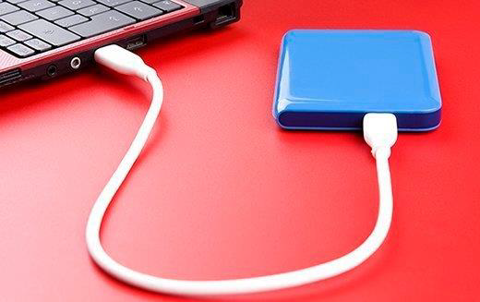

An external hard disk drive. 25

SSDs store data on nonvolatile flash memory chips. Unlike spinning disk drives, SSDs have no moving parts. They are increasingly found in all types of computers, although they remain more expensive than HDDs. Although they haven't gone mainstream yet, some manufacturers are shipping storage devices that combine a hybrid of RAM and flash.

Intel's 3D XPoint-based Optane SSD

Optical data storage is popular in consumer products, such as computer games and movies, and is also used in high-capacity data archiving systems

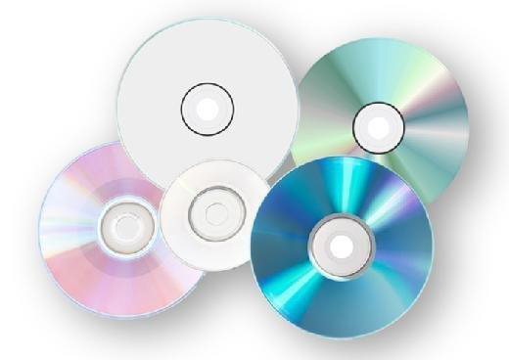.

Various optical media formats 26

Flash memory cards are integrated in digital cameras and mobile devices, such as smartphones, tablets, audio recorders and media players. Flash memory is found on Secure Digital cards, CompactFlash cards, MultiMediaCards and USB memory sticks.

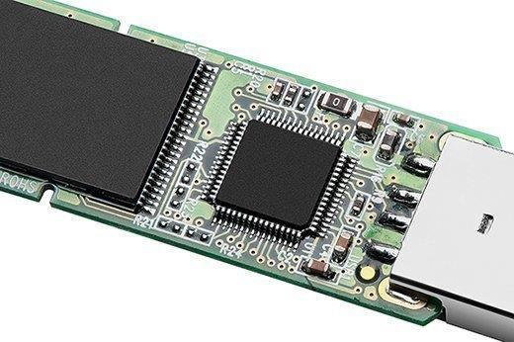

Flash memory

Physical magnetic floppy disks are rarely used in the era of flash. Unlike older models, newer computer systems are not equipped with slots to insert floppy disks, which emerged as an alternative to magnetic disk. Use of floppy disks started in the 1970s but was phased out in the late 1990s. Virtual floppy disks are sometimes used in place of the 3.5-inch physical diskette, allowing users to mount an image file mapped to the A: drive on a computer.

Enterprise storage networks and server-side flash

Enterprise storage vendors provide integrated NAS systems to help organizations collect and manage large volumes of data. The hardware includes storage arrays or 27

storage servers equipped with hard drives, flash drives or a hybrid combination, and storage OS software to deliver array-based data services. 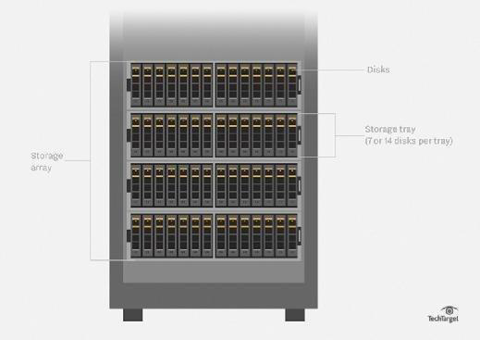

ORACLE CORP.

Diagram of a storage array

The storage management software offers data protection tools for archiving, clones, copy data management, replication and snapshots. Data reduction features, including compression, data deduplication and thin provisioning, are becoming standard features of most storage arrays. The software also provides policy-based management to govern data placement for tiering to secondary data storage or a hybrid cloud to support a disaster recovery plan or long-term retention.

Since 2011, an increasing number of enterprises have implemented all-flash arrays outfitted only with NAND flash-based SSDs, either as an adjunct or replacement to disk arrays. 28

PURE STORAGE 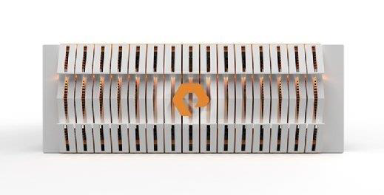

Pure Storage's Flash Blade enterprise storage array

Unlike disk, flash storage devices do not rely on moving mechanical parts to store data, thus offering faster access to data and lower latency than HDDs. Flash is nonvolatile, allowing data to persist in memory even if the storage system loses power. Disk-based storage systems require onboard battery backup or capacitors to keep data persistent. However, flash has not yet achieved an endurance equivalent to disk, leading to hybrid arrays that integrate both types of media.

There are three basic designs of networked storage systems. In its simplest configuration, direct-attached storage (DAS) involves the internal hard drive in an individual computer. In the enterprise, DAS can be a cluster of drives in a server or a group of external drives that attach directly to the server though the Small Computer System Interface (SCSI), Serial Attached SCSI (SAS), Fibre Channel (FC) or internet SCSI (iSCSI).

NAS is a file-based architecture in which multiple file nodes are shared by users, typically across an Ethernet-based local area network (LAN) connection. The advantage of NAS is that filers do not require a full-featured enterprise storage operating system. NAS devices are managed with a browser-based utility, and each node on the network is assigned a unique IP address. 29

Closely related to scale-out NAS is object storage, which eliminates the necessity of a file system. Each object is represented by a unique identifier. All the objects are presented in a single flat namespace.

A storage area network (SAN) can be designed to span multiple data center locations that need high-performance block storage. In a SAN environment, block devices appear to the host as locally attached storage. Each server on the network is able to access shared storage as though it were a direct-attached drive.

Advances in NAND flash, coupled with falling prices in recent years, have paved the way for software-defined storage. Using this configuration, an enterprise installs commodity-priced SSDs in an x86-based server, using third-party storage software or custom open source code to apply storage management.

Nonvolatile memory express (NVMe) is a developing industry protocol for flash. Industry observers expect NVMe to emerge as the de facto standard for flash storage. NVMe flash will allow applications to communicate directly with a central processing unit (CPU) via Peripheral Component Interconnect Express (PCIe) links, bypassing SCSI command sets transported to a network host bus adapter. NVMe over Fabrics (NVMe-oF) is intended to speed the transfer of data between a host computer and flash target, using established Ethernet, FC or InfiniBand network connectivity.

A nonvolatile dual inline memory module (NVDIMM) is hybrid NAND and DRAM with integrated backup power that plugs into a standard DIMM slot on a memory bus. NVDIMMs only use flash for backup, processing normal calculations in the DRAM. An NVDIMM puts flash closer to the motherboard, presuming the computer's manufacturer has modified the server and developed basic input-output system (BIOS) drivers to recognize the device. NVDIMMs are a way to extend system memory or add a jolt of high-performance storage, rather than to add capacity. Current NVDIMMs on the market top out at 32 GB, but the form factor has seen density increases from 8 GB to 16 GB in just a few years. 30

Major data storage vendors

Consolidation in the enterprise storage market has winnowed the field of primary NAS and SAN array vendors in recent years. Storage vendors that penetrated the market with disk products now derive most of their sales from all-flash or hybrid flash. Market-leading vendors include:

* • Dell EMC, the storage division of Dell Technologies
* • Hewlett Packard Enterprise (HPE)
* • HPE Nimble Storage
* • Hitachi Vantara
* • IBM Storage
* • Infinidat
* • Kaminario
* • NetApp
* • Pure Storage
* • Quantum Corp.
* • Qumulo
* • Tegile Systems, part of Western Digital Corp.
* • Tintri

Smaller NAS vendors include Drobo, iXsystems, Panasas and Synology. Leading hyper-converged infrastructure (HCI) vendors include Atlantis Computing, Cisco (HyperFlex), HPE SimpliVity, Nutanix, Pivot3, Promise Technology, Scale Computing and VMware VSAN. Most major enterprise storage vendors also offer branded HCI and converged infrastructure products.

